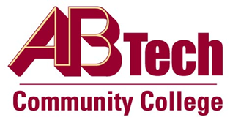

# Asheville-Buncombe Technical Community College (A-B Tech) Policy Manual

## Policy 316: Scrap Materials

It is the policy of the Board of Trustees that all accumulated materials and equipment in excess of the needs of a department shall be declared as scrap and disposed of in accordance with state regulations. Examples of scrap materials are paper products, culinary by-products, metals from vocational departments or remains of cannibalized equipment items. All scrap materials remain property of the College.

Revenue generated from the disposal of scrap materials will be considered unrestricted income of the College unless otherwise determined by the Vice President of Operations/CIO.

The Purchasing Agent will administer the disposal of scrap materials.

### Scope

Applies to all scrap supplies, materials and equipment used and owned by the College.

### Definitions

Scrap materials include supplies, materials or equipment that is obsolete or requires excessive repairs and the costs are prohibitive.

### References

NCCCS Purchasing and Equipment Manual, Third Edition, Section C

Reviewed by the Executive Leadership Team, November 29, December 5 and 12, 2012

Reviewed by the Board of Trustees Executive Committee, December 20, 2012

### Policy Owner

Vice President of Operations/CIO, Ext. 7900

Approved by the Board of Trustees on January 28, 2013.